SAMPLE STROKE DRILL SHEET
FLY DRILLS
- Body position butterfly kicking drill
  - Caterpillar arms at side
  - Front Kick (Hands by Side)
This drill helps you become comfortable with your kick and raising your head to breath. To do this drill, kick on your front with your hand by your side. Every 2 dolphin kicks, lift your head just out of the water and take your breath. You can see Jeremy breathing every 4 or 5 kicks in some of his strokes which is okay to do. I prefer swimmers to breathe every 2 kicks as it helps with the timing of the breathing in butterfly swimming.
- Keyhole Drill
  - It helps swimmers time the pull and the breathing. Start by sculling in the water with your arms sculling back and forth and doing a freestyle kick. When you’re ready, do a dolphin kick and pull through the water and take a breath during the pull. Your arms should pop out of the water at the end of the pull as you drive yourself forward. Your pull-through should be in a shape of an old stone keyhole, hence the name of the drill. To get back into the sculling position, bring your arms back under your body and begin sculling again
- One arm butterfly swimming
  - Arm at side
  - Arm in front
- 3,3,3 butterfly swim drill.
  - 3-L arm-3 r-Arm -3 swim
  - Or 2-2-2
- Butterfly push-through drill
  - As you reach the end of the catch, give a strong and big kick, accelerate speed, and give a powerful pull so that your arms shoot out over the water.
  - Do not go into the recovery phase of the arm stroke, just do 1-2 butterfly kicks to go back into the starting position and repeat.
- Butterfly kick on your back
  - Small and fast- hips at the surface- little upper body movement
- No kick butterfly swimming drill
  - Give a strong arm stroke through the water, without kicking. Take a breath as your body reaches the highest point in the water. Recover using your core to propel your arms forward. You will notice that your feet snap down a little bit in the water anyway.
- Butterfly swimming with a free kick
- Closed fist butterfly swimming.
- Angel butterfly swim drill
  - Exactly like it looks concentrate on pull to hip- recover close or on top of water- works best with snorkel
- Body position butterfly swimming

HAND ENTRY
Your hands should enter the water shoulder-width apart or slightly wider if you prefer it.
Enter with your middle fingers first and your palms facing down as this will set you up to immediately catch the water.
Entering with the thumbs first is not a problem as long as the angle of the hands isn’t over-exaggerated. Ideally, if you want to use this hand entry the angle of the hands should be 30°.
Problems start to occur when entering with the thumbs and index fingers at an angle of more than 60°. This setup will increase the time it takes for you to get into the catching position. Additionally, it internally rotates the shoulder joints which adds extra stress that can lead to shoulder injuries in the long run. In some cases, it may also cause the swimmer to pull too wide.
CATCH
Bend the elbows simultaneously as they start to pull backward, allowing them to effectively engage all major upper body muscles such as the chest, lats, upper back, and shoulders as well as smaller muscle groups like the biceps to allow for maximal power output.
Common mistakes in the catch phase include sweeping outwards away from the body before starting to pull back. It will not only cause the body to drop in the water but will also increase the time it takes to get into the pulling phase. Ideally, once the hands have entered the water, bend the elbows backward while pulling more inwards towards your hips as you prepare to enter the pulling phase of the stroke.
Another mistake is pulling down towards the floor to lift the head out of the water for the breath. In swimming, you always want to focus your energy on pulling backward to generate forward propulsive force. Focus on a strong down kick to lift the upper body rather than expending energy from your catch to lift out of the water.
THE PULL
This arm movement takes place after the elbows have bent roughly 60°, usually just in front of the upper chest and shoulder joints, and ends after the hands have passed the hips and started exiting the water for the recovery phase.
This is the second-largest phase of the butterfly arm movement and is where most of the forward propulsive force comes from.
- Hands start wide and then sweep in underneath your belly button, with the forearms staying perpendicular to your body throughout most of the movement, from there they’ll then sweep back out allowing them to pass the hips and exit the water.
- The out sweep starts once the hands have reached their narrowest point underneath the belly button and is more of a pushing movement rather than a pull, allowing the hands to shoot out of the water as you prepare to enter the final phase of the butterfly arm stroke.
  - a common mistake swimmers make is not sweeping the hands in far enough so that they are under the belly button. This will create additional torque as your hands are further away from your center of mass.
  - make sure that you aren’t ending your pull before the hands have passed the hips and started exiting the water. The arms should be fully extended and the tricep muscles at maximal flexion. Ending your pull prematurely will cause you to lose a lot of power.
One of the most important parts of the pulling phase is to maintain a high elbow position, allowing the hands and forearms to effectively pull and push water backward. If your elbow position drops, you’ll be pushing the water more downwards rather than back, causing your hips to drop and chest to lift, which creates an inefficient butterfly stroke.
Hand Exit
Exit your hands with the pinky-fingers first as you bring them out of the water to enter the recovery phase of the arm movement.
THE RECOVERY
The final stage of the butterfly arm movement and from a range of motion perspective- the largest. From a technical perspective.
- The recovery phase of the butterfly arm movement starts as soon as the hands exit the water and ends when they start to re-enter the water for the catching phase of the next stroke cycle.
- Keep the arms low above the surface bringing them over in a circle-like motion as you prepare to re-enter the water. Make sure that your arms are mostly straight throughout the movement and that they aren’t touching the water until re-entry.
- Keep it relaxed and use mostly momentum to bring your arms over. If you initiated the pulling phase correctly, you should be able to shoot your arms over back into the catching phase without much effort.
  - A common mistake swimmers make is not using momentum to carry their arms over. This causes the swimmer to use the back and shoulder muscles to bring their arms over, defeating the point of the recovery phase. It may also cause a drop in your hips which will create extra drag.
THE KICK
There are two kicks per stroke cycle. These dolphin kicks are synchronized with the butterfly arm movements:
- THE FIRST LEG KICK, PERFORMED JUST AS YOUR HANDS ENTER THE WATER, IS THE SHORTER AND LESS POWERFUL OF THE TWO.
- Your speed is at its lowest, because your hands slow down your body’s forward motion as they enter the water; here the leg kick cancels out the braking effect of your arms and raises your hips, so that you can pull properly with your hands
- The second leg kick, performed as you complete the pull phase, is longer and more powerful than the first and helps push up your hips that have been “pushed down” by the movement of your arms
WHAT HAPPENS IF YOU ONLY USE A SINGLE-LEG KICK? When you do not have the strength to really push back with your arms, your hands come out of the water halfway through the stroke and there is no time to insert a second leg kick. THIS IS WHERE you will have to focus on your arm pull

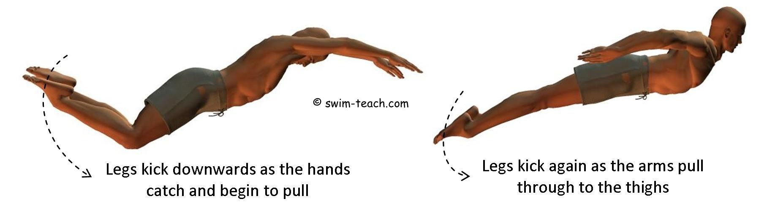
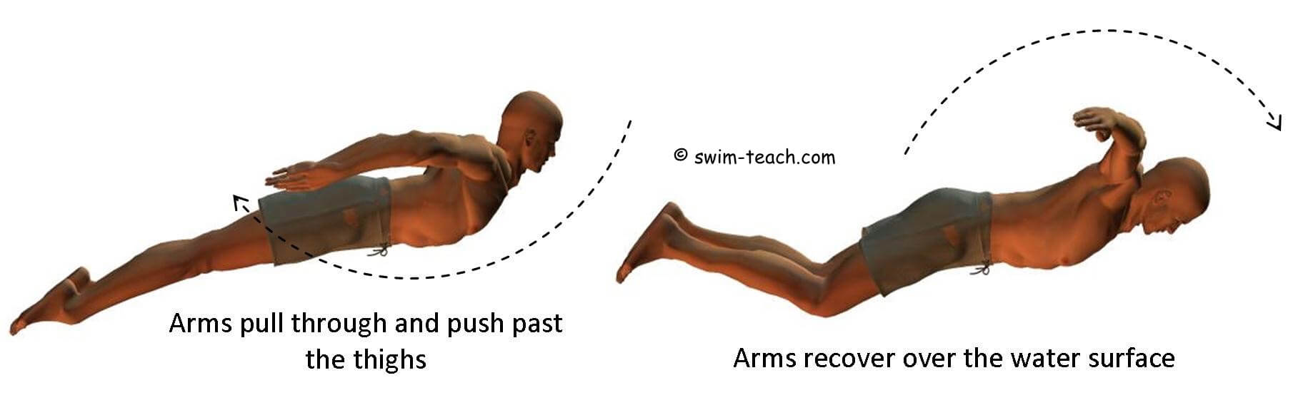
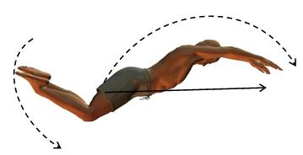

BACKSTROKE DRILLS:
- Streamline Kick on Back + Cup on Forehead
  - Half full-on forehead -try a couple of strokes
- 12-Kick Switch (WITH OR WITHOUT FINS)
  - Same as a 6-kick switch- head always looking up good shoulder rotation. balance on side
- 3 Strokes + 12 Kicks (with or without fins)
  - Balance on side, head up
- Dolphin Kick + Backstroke Arms
- Catch Up Drill
- Double arm backstroke drill with flutter kick/ practice shallow pull w/full recovery
- 1- ARM SWIM- Opposite arm on side
- Pause Drill
- Slow Motion Backstroke
- Slow motion to fast (over fast) turnover)

BREASTROKE DRILLS
- Clenched Fist Drill
- Butterfly Legs Drill
- Freestyle Legs Drill
- Head Above the Water
  - Chin just above surface/fast stroke
- One Arm Drill
  - Opposite arm out front
- Elbow Close Together
  - After pull/before recovery try to make elbows touch
- Sculling: w/buoy
- In-Sweep Drill
  - Start pull to Y-delay lift of head-3 x then full stoke-When to go to air
- Windshield Wiper Drill
  - Work your out-sweep before bringing both arms together.
  - You must keep your elbows high in line with shoulders and do flutter kicks.
  - Keep a good body position – straight spine and high hips – for desired results and less fatigue.

FREE DRILLS
- Closed-Fist Freestyle
- Underwater Freestyle With Swim Fins
- One Arm Drill
- Catch-up Drill
- Fingertip drill
- Hand-Drag Drill- hands at wrist underwater
- Tarzan
- Sculling- Front-Mid and hip
- Over-Kick Freestyle Drill
- Slow Swimming
- Dolphin-Kick Freestyle- develop a rhythm.
- Dip and kick drill- with or without paddles (Use fins for body position)
  - One arm forward-one arm at hip
  - Cock your elbow up and recover hard rotating opposite shoulder
  - 3-Laft arm…3-right arm…3 full stroke fast

